


University of South Alabama
ISC 472-101

Hospital Cost Data Analysis

The Query Queens
Hong Nguyen, Jadaea Lockett, Chloe Goff

Spring 2026

Instructor:

Andy Cobb
ISC 472-101 Advanced Data Management
Table of Contents
Introduction 3
Data Quality 3
Research Questions 4
Rejected Research Questions 4
Analysis 5
Visualizing the Findings 8
Presenting the Findings 9
Conclusion 17
Works Cited 18

Introduction
The Query Queens were assigned a project to analyze a large public dataset where they would act as both Type Ⅰ and Type Ⅱ data scientists . All members were expected to collaborate in order to select a dataset, develop insightful research questions, inspect and visualize the chosen data using various software and tools, and use the final analyses to answer the research questions.
The team first began the project by individually sifting through the provided lists of datasets, reviewing the featured data, and forming a list of potential candidates. Once each team member had chosen a few different resources, they collectively narrowed down the lists. After this refinement, the team chose a hospital provider cost report dataset created by the U.S. department of health and human services.

Data Quality
Upon initially importing the dataset into SQL Server Management Studio (SSMS), several data type issues were encountered. The data types automatically assigned by SSMS were too small to handle what was in the dataset, so each variable had to be manually inspected and changed accordingly. This proved to be the most tedious part of the importing process. In addition, when going through the analysis process, there was missing information on the ‘TC’ facility type. There was only one record of it in the database, with most of the values being NULL.

Research Questions
The selected dataset features both financial and operational data from hospitals across the country. With records dating back to 2011, the team was presented with a substantial amount of information about medical providers’ income, debt, service capacity, employees, and much more. The Query Queens developed four different research questions that they aimed to answer through this analysis:
- Do certain facility types tend to make more income per bed?
- Do hospitals in certain states have better cost/income ratios?
- Which states have the highest Medicaid usage?
- How does the total number of employees affect overall profitability?

Rejected Research Questions
Additionally, the team found two research questions that were ultimately rejected. After research was conducted through the chosen dataset, it was found that there were a few key details missing that were needed to answer these questions. The rejected research questions include:
- Do wealthier hospitals maintain a higher capacity?
- Does bed availability directly correlate with revenue generation?
The Query Queens had trouble defining patient capacity and bed availability within certain hospitals. While there was existing data on the number of beds, there was not any data to determine which beds were occupied versus available at any given time.

Analysis
In order to find answers to the selected research questions, the team first downloaded a csv file from the dataset on data.gov. All data used for the analyses are from the 2023 file. After the initial download, they then proceeded to create a database in SQL Server Management Studio and imported this csv as a flat file to create a table. There was a minor issue with the import on the first attempt where the default sizes of the integer data types were not large enough for the numbers contained within the csv. To address this, the team increased all integer sizes before finishing the import. Once this was done, they were able to write the following SQL queries to begin the analysis of the data.
- Do certain facility types tend to make more income per bed?
SELECT CCN_Facility_Type, AVG((Net_Income)/(Number_of_Beds)) AS [AVGIncomePerBed],
CASE
WHEN AVG((Net_Income)/(Number_of_Beds)) > 0 THEN 'Revenue'
ELSE 'Debt'
END AS [DebtOrNot]
FROM CostReport_2023_Final
WHERE CCN_Facility_Type <> 'TC' --Do not inlclude 'TC', it has nothing in there.
GROUP BY CCN_Facility_Type
ORDER BY AVGIncomePerBed
To reduce bias when analyzing income to bed ratio, the average was taken for each facility. Additional code was included to improve data organization and readability. ‘TC’ facility types were removed because they contained only one record and no relevant data.

- Do hospitals in certain states have better cost/income ratios?
--Query 1:
SELECT
[Hospital_Name],[State_Code],[Total_Income],
[Total_Costs],
FROM dbo.[CostReport_2023_Final]
WHERE [Total_Income] IS NOT NULL
AND [Total_Costs] IS NOT NULL;

--Query 2:
SELECT
[State_Code],
AVG([Total_Costs] * 1.0 / NULLIF([Total_Income], 0)) AS Cost_Income_Ratio
FROM dbo.[CostReport_2023_Final]
GROUP BY [State_Code]
ORDER BY Cost_Income_Ratio ASC;
For this part of research, the team started by ensuring that only complete and reliable financial data was obtained in the analysis. The first query selects hospital name, state code, total income, and total costs, while refining any records where total income or total costs are null.
The second query calculates the cost-to-income ratio for hospitals throughout each of the states. This is done by dividing the total costs by the total income for each hospital and then averaging the values across the hospitals in the same state. The NULLIF function helps prevent division-by-zero errors and is then stored under Cost_Income_Ratio.
With the utilization of state codes, the data is then grouped so that each state has a single average ratio. The results are ordered in ascending order, allowing the team to compare and determine which states have better cost-to-income ratios. States with lower ratios show to have more efficient hospital operations, as costs are lower comparative to income, while higher ratios are shown to be less efficient.
- Which states have the highest Medicaid usage?

ALTER TABLE dbo.CostReport_2023_Final
ADD Adopted_Medicaid_Expansion BIT;

UPDATE dbo.CostReport_2023_Final
SET Adopted_Medicaid_Expansion = 1
WHERE State_Code IN ('AZ', 'AK', 'CA', 'OR', 'NV', 'UT', 'ID', 'WA', 'MT', 'CO', 'NM', 'ND', 'SD', 'NE', 'LA', 'OK', 'AR', 'MO', 'IA', 'MN', 'IL', 'IN', 'MI',
'KY', 'OH', 'WV', 'NC', 'VA', 'PA', 'DE', 'NJ', 'RI', 'NY', 'NH', 'ME', 'HI',
'VT', 'MA', 'CT', 'MD', 'DC');

UPDATE dbo.CostReport_2023_Final
SET Adopted_Medicaid_Expansion = 0
WHERE Adopted_Medicaid_Expansion IS Null;

SELECT
State_Code,
COUNT(Hospital_Name) AS Hospital_Count,
Adopted_Medicaid_Expansion,
SUM(Net_Revenue_from_Medicaid + Net_Revenue_from_Stand_Alone_CHIP) AS Total_Low_Income_Health_Insurance
FROM [HospitalProviderCostReport].[dbo].[CostReport_2023_Final]
GROUP BY State_Code, Adopted_Medicaid_Expansion
ORDER BY Total_Low_Income_Health_Insurance DESC;

When analyzing the dataset to determine which states had the highest Medicaid usage, the team wanted to also see if the Medicaid expansion affected these results in any way. The query above first alters the original table to add a column named Adopted_Medicaid_Expansion that stores a bit value. After, it sets this bit to 1 for all states that have adopted the Medicaid expansion, and later sets the other states to 0. Then, the query selects all state codes, a count of all hospitals, and the sum of Medicaid revenue and CHIP revenue. CHIP stands for children’s health insurance program and is under the Medicaid umbrella. The query creates a new column alias named Total_Low_Income_Health_Insurance to store this sum. The team then groups these results by the state code in order to have one row per state, and orders them descending by the total low income health insurance.
- How does the total number of employees affect overall profitability?

SELECT
State_Code,
Hospital_Name,
SUM(Total_Income - Total_Costs) AS Overall_Profitability,
FTE_Employees_on_Payroll
FROM [HospitalProviderCostReport].[dbo].[CostReport_2023_Final]
GROUP BY State_Code, Hospital_Name, FTE_Employees_on_Payroll
ORDER BY FTE_Employees_on_Payroll DESC;

The above query selects the state code, hospital name, number of employees on payroll, and creates an alias column of total income minus total costs as the overall profitability. It then groups these by columns by the state code, hospital name, and number of employees on payroll. Lastly, the query orders by the number of employees on payroll descending so that the team can automatically see how the number of employees affects the profitability.

Visualizing the Findings
The team connected to the newly created database through Tableau to visualize the findings. Within this platform, they created a new workbook filled with worksheets and dashboards for each research question.

Presenting the Findings
Using the SQL queries mentioned earlier in the report, along with the dashboards created in Tableau, the team was able to create a story for each of the research questions identified. In the following section, one may view each research question, its corresponding answer gained through the analysis, explanations from the analysis, and a visualization.
- Do certain facility types tend to make more income per bed?
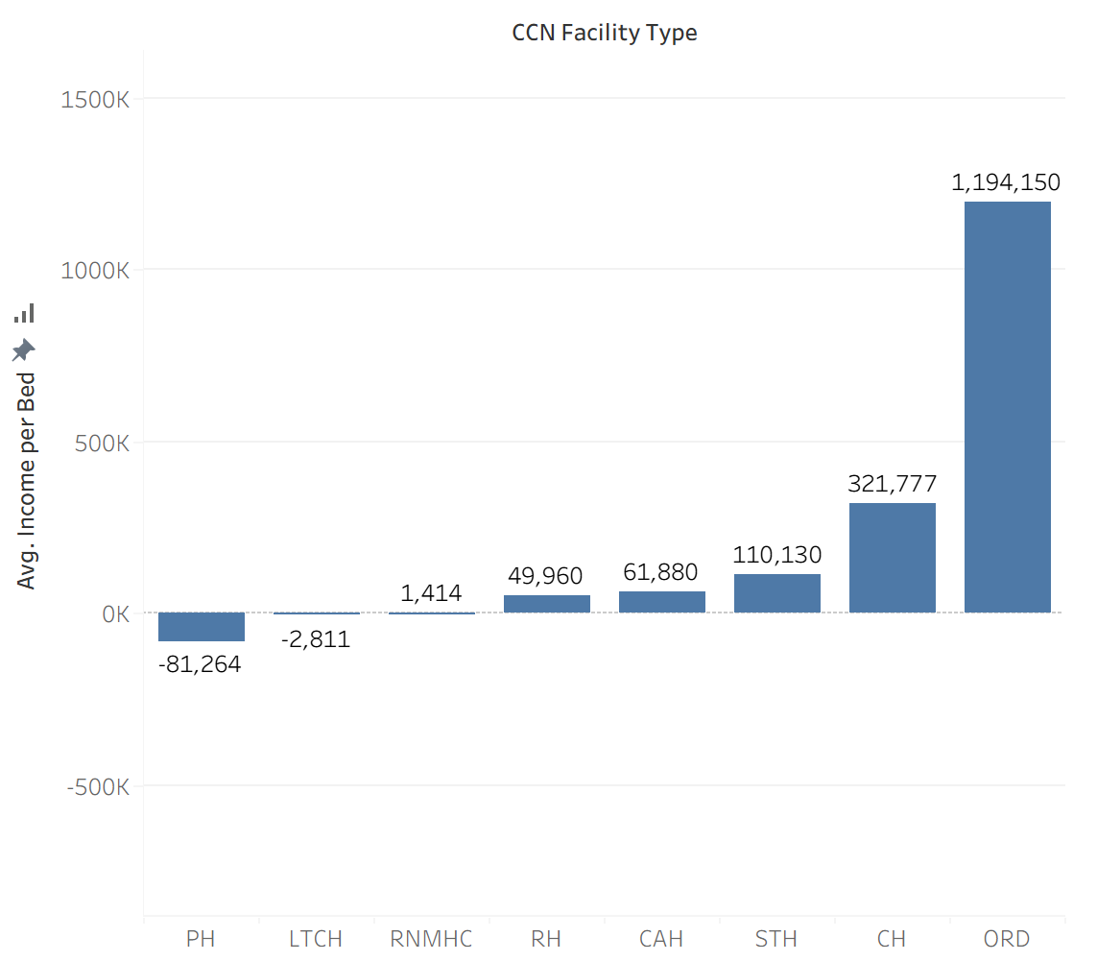
- PH: Psychiatric Hospitals
- LTCH: Long-Term Care Hospitals
- RNMHC: Religious Non-medical Health Care Institutions
- RH: Rehabilitation Hospitals
- CAH: Critical Access Hospitals
- STH: Short-term (General and Specialty) Hospitals
- CH: Children Hospitals
- ORD: Reserved for hospitals participating in ORD demonstration project
Before presenting the findings, it is important to first highlight one major facility type: short-term hospitals (STH). STH is the most common facility type in the United States and represents the type of hospital most individuals encounter in everyday life. Based on the SQL query and visualization, ORD (Office of Research and Demonstrations) exhibit the highest average, approximately $1,194,150 per bed, while PH (Psychiatric hospitals) exhibit the lowest with approximately -$81,264 per bed on average. ORD are STH hospitals that received special designation for research purposes, despite STH dominating the rest of the facilities, ORD is making exceptionally more than compared to the rest. This result is likely influenced by the limited sample size of ORD facilities. The dataset only contains eight ORD records, each with relatively high net income with bed counts ranging from 9 to 152, compared to the 3,236 records for STH facilities. As a result, it can be concluded that ORD is an outlier and likely skewed the results. In contrast, PH facilities were well represented, suggesting that the observed results may be more reliable. The lower average income per bed may be due to longer patient stays, resulting in a lower turnover rate and reducing revenue intensity per bed. This is also shown by how LTCH (Long-Term Care Hospitals) are second to last in revenue generation per bed. In addition, PH performs fewer high-cost procedures, which can further limit the revenue generated per bed. Overall, the conclusion of which facility type makes more could better be determined by the structure of the hospital and the different revenue streams. Bed revenue is not the strongest indicator of which facility type makes the most.
- Do hospitals in certain states have better cost/income ratios?
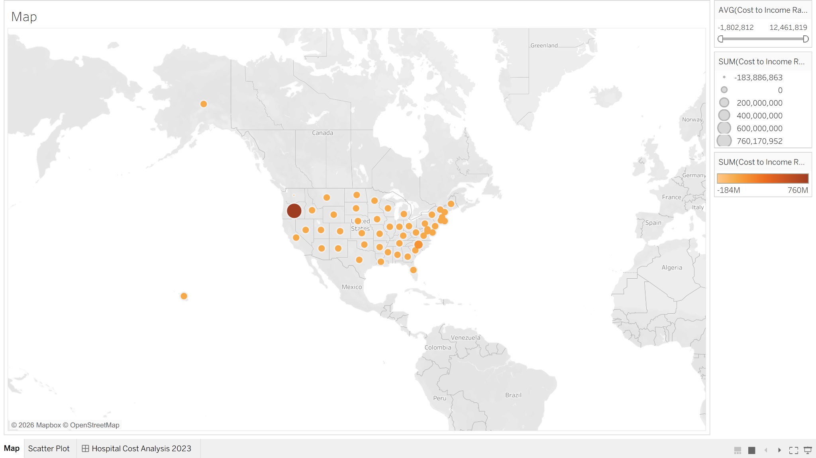
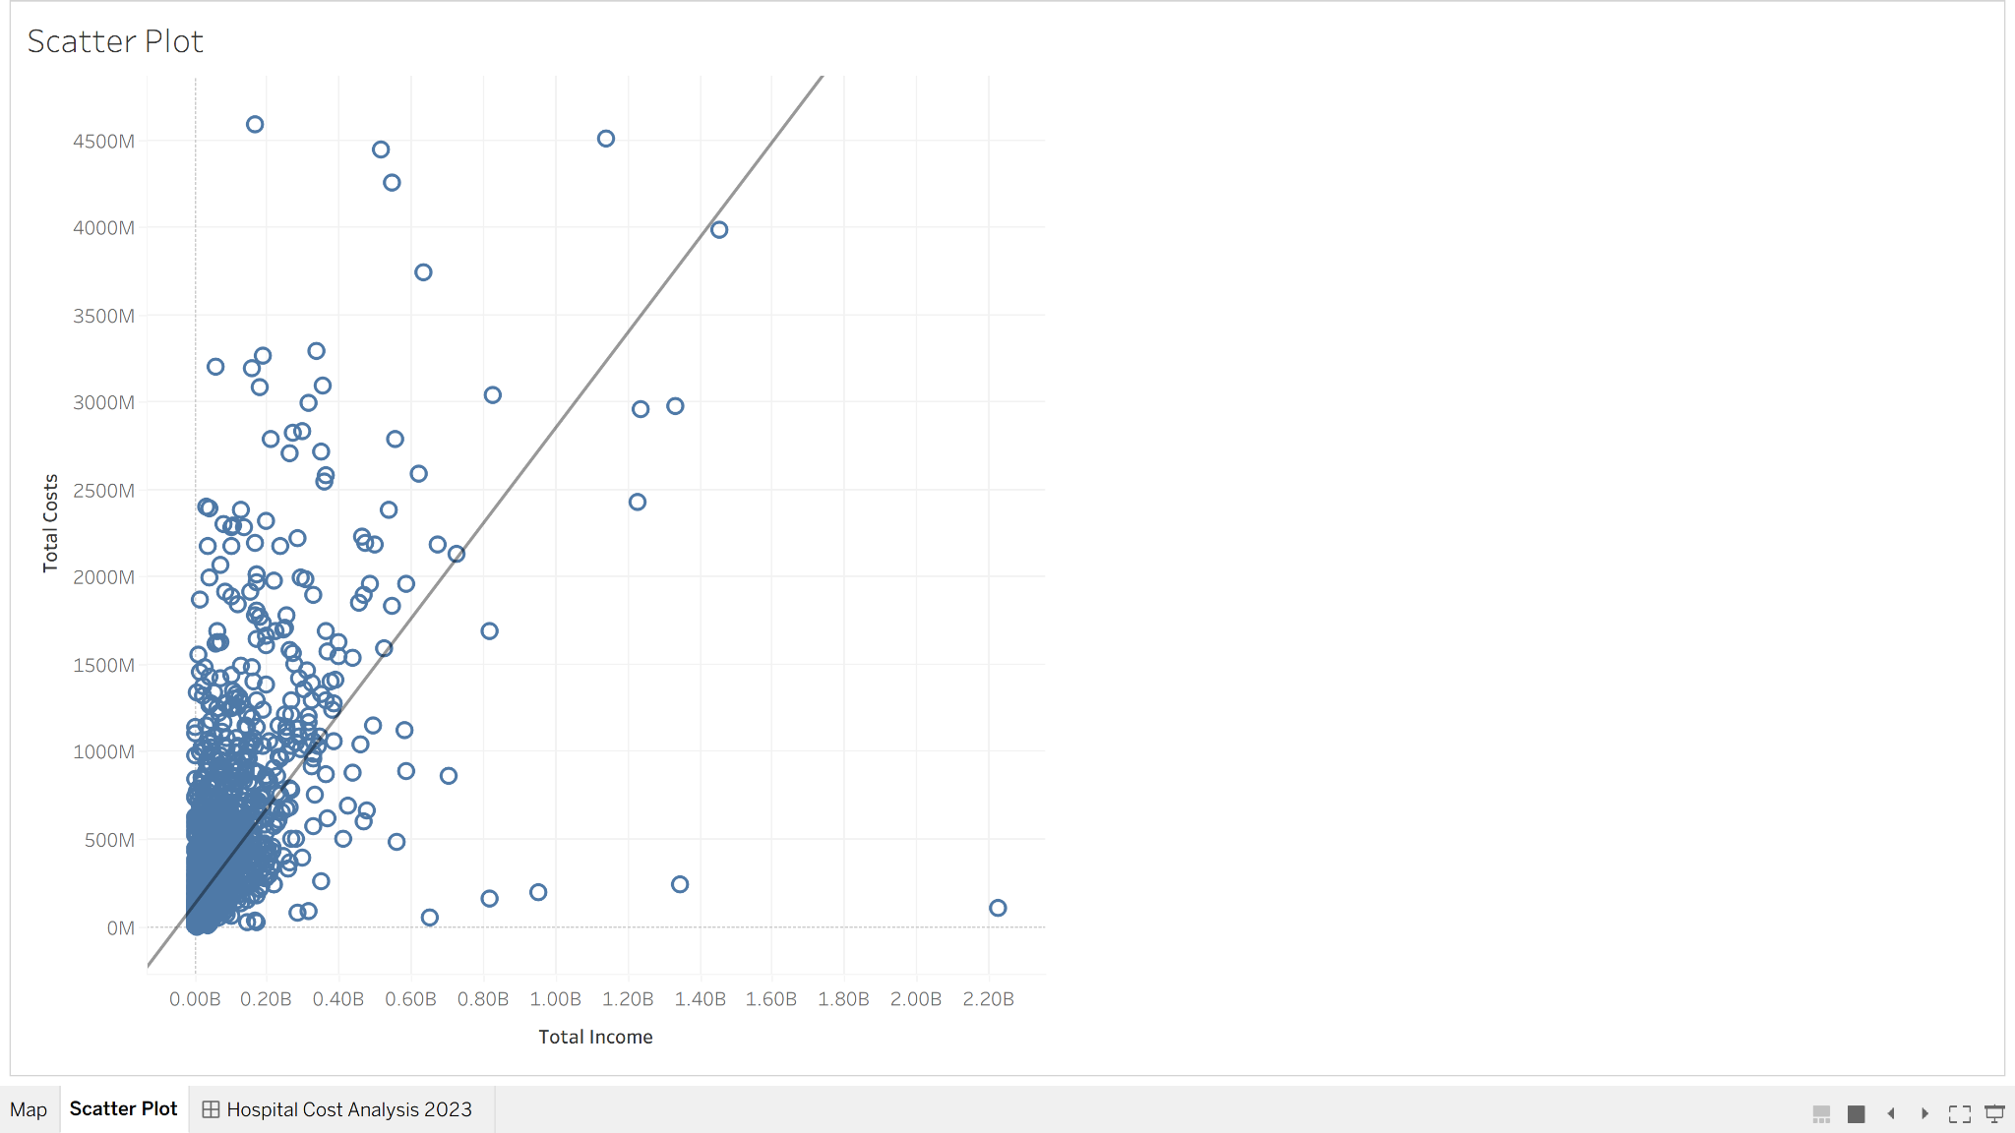
To present the findings for this research question, the team decided to use a map and a scatter plot to effectively show the cost-to-income ratio. Throughout, research ratios that are lower are considered “better”. This indicates that operational costs are relatively low to the income generated. The map allows for a geographic comparison of the financial performance across the United States, the use of state codes allowed the team to group average ratios. By averaging the ratios by states, we were able to see which regions operate more efficiently, with lower ratios being more efficient and higher ratios showing less efficiency.
The scatter plot provides an unfiltered view of individual facility performance by showing total costs against total income. This visualization allowed us to see trends as hospitals increase in scale, with the shifts between costs and income. The trend line distinguishes which hospitals are operating successfully versus those where costs have surpassed total income, the plot confirms that a higher volume of income does not guarantee a better cost-to-income ratio. With the combination of these visualizations the team was able to conclude that while efficiency varies by state, the cost-to-income ratio is important for understanding the financial health of a facility regardless of location.
- Which states have the highest Medicaid usage?
This question was chosen as the team found the difference in numbers within the “Net Revenue from Medicaid” column quite interesting. Additionally, they recognized that the information identified could be valuable to government agencies since the program is funded by both state and federal funds. Knowing which states have the highest usage could help these agencies to better determine how to allocate their resources. For this visualization, the columns “Net Revenue from Medicaid” and “Net Revenue from Stand Alone CHIP” were added together as a calculated field named “Total Revenue from Low Income Health Insurance”. The following figure outlines which states have the highest Medicaid and CHIP usage.
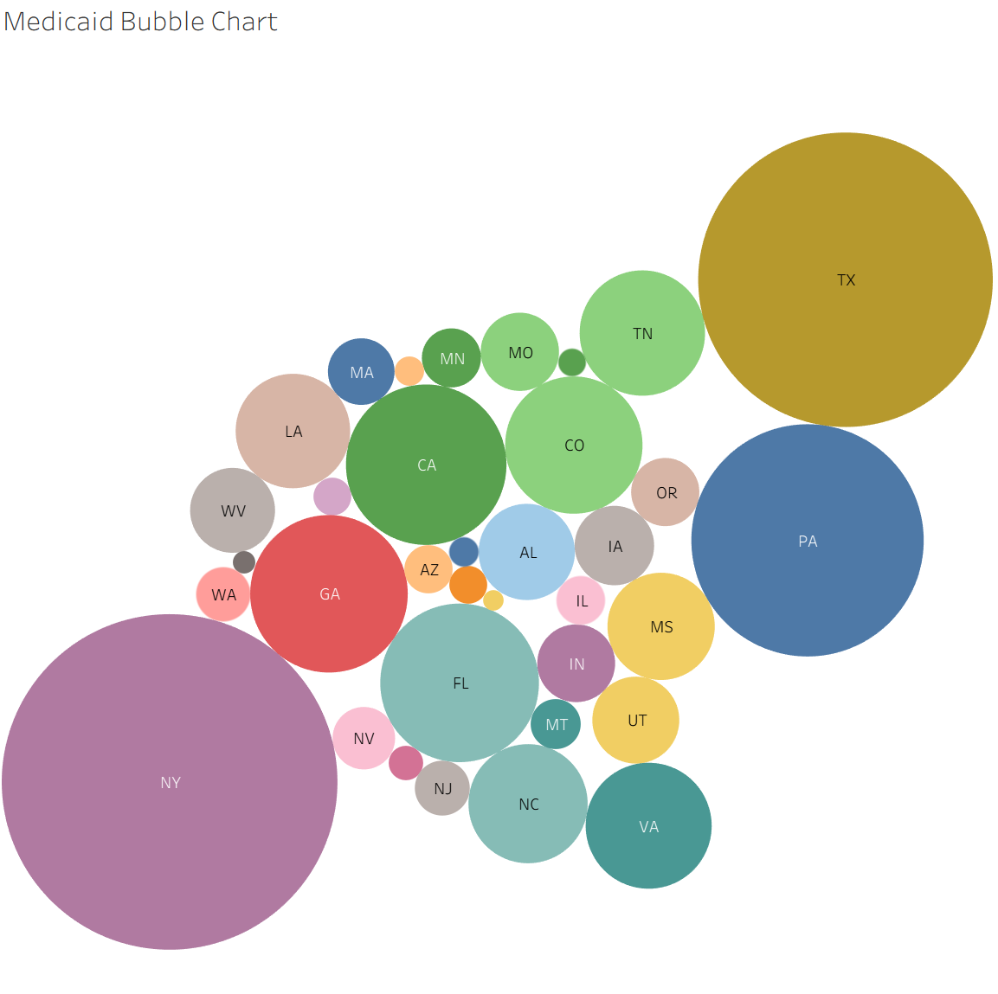
Originally, the team used a bar chart to visualize the data derived for this question. However, it was difficult to read the results for all fifty states. On the second attempt, they chose to use a bubble chart which was much easier to use in viewing the findings. While not all states can be seen at first glance here, the large, and important, states are clearly visible.
The “Total Revenue from Low Income Health Insurance” was placed on the size card to present the states with the highest usage in the largest circles. The “State Code” was placed on the color card to provide some dimension within the pictured results. Additionally, a filter of “Adopted Medicaid Expansion” was added so that the team could easily find the highest Medicaid usage in both the states that have not yet adopted the Medicaid expansion and those that had.
In the figure above, we can see that New York has the highest Medicaid usage overall with a total revenue of $9,587,342,273 throughout all facilities featured in the dataset. Texas is just behind with a total revenue of $7,383,269,470 and Pennsylvania is third in line with $4,592,372,319. An interesting find in this analysis is that Texas is one of the states who has not yet adopted the Medicaid expansion; however, still has one of the top three Medicaid usage rates in the United States. The following figures represent the results when filtered by the Medicaid expansion to show the differences.
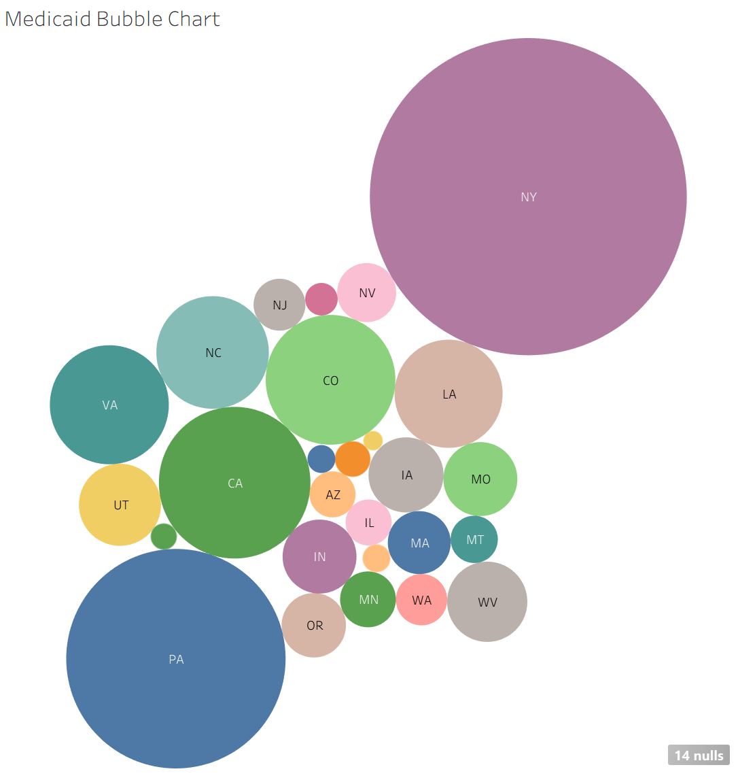

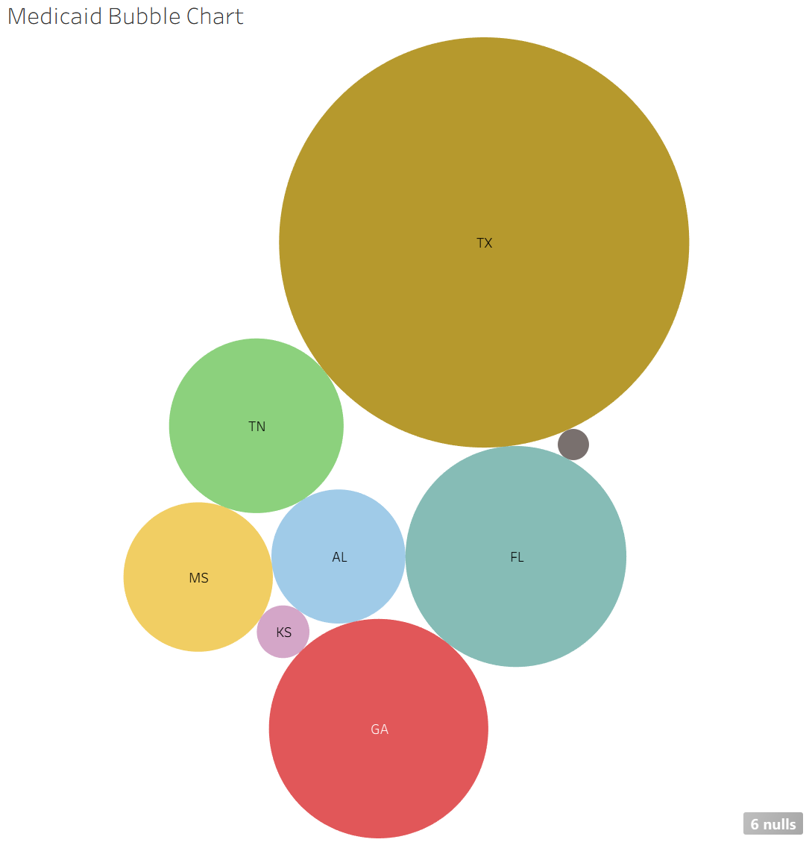

- How does the total number of employees affect overall profitability?
This question was chosen by the Query Queens because of the difference that was seen in overall profitability across different facilities. The team wondered if the number of people employed affected this at all. Additionally, this could be used throughout hospitals to refine positions available depending on the outcome of this analysis. The team created a calculated field named “Overall Profitability” using the difference of “Total Income” minus “Total Costs”. The figure below shows the effect that the number of employees can have on a hospital’s overall profitability.
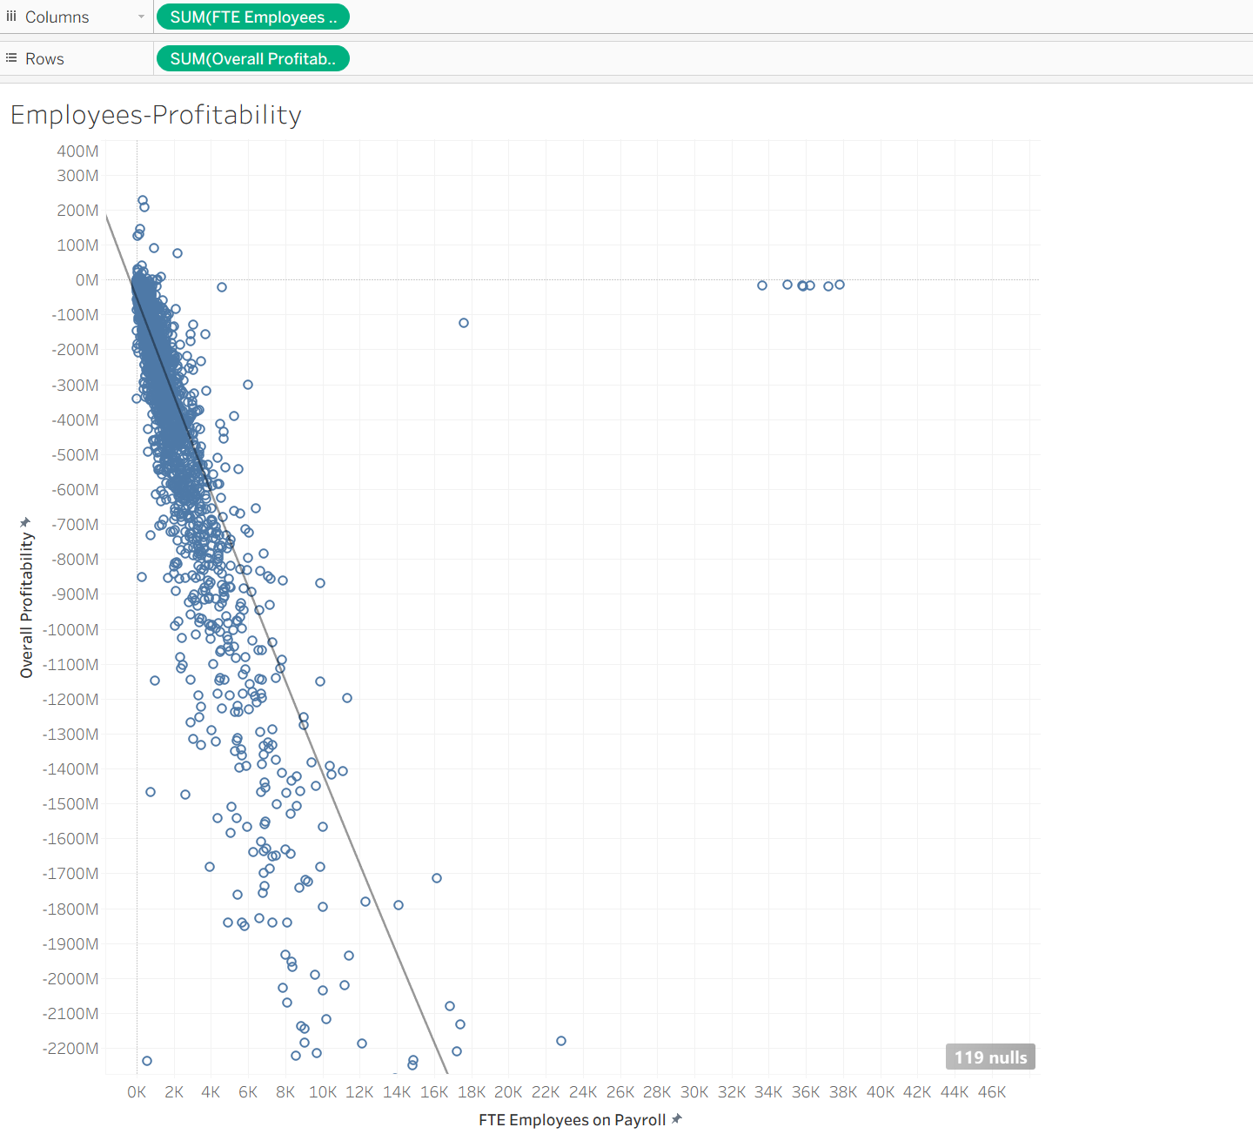
The team chose to use a scatter plot for this visualization to determine whether there was any kind of correlation between the number of employees and the overall profitability. This was formed using an x-axis of “FTE Employees on Payroll” and a y-axis of “Overall Profitability”. The team decided against any marks on this graph as the results were easily seen as is.
The data pictured in the image clearly shows a negative correlation between profitability and the number of people employed. For example, the highest profitability on this graph was recorded from Banner Ocotillo Medical Center at $228,292,638. This medical center has just 334 employees on their payroll. On the contrary, the lowest profitability was recorded from Brigham and Women’s Hospital at -$2,249,944,472 with 14,857 employees. Ultimately, this analysis shows that a higher number of employees negatively affects overall profitability.

Conclusion
After completing this project, there were a few things we learned. First, we realized how time consuming it can be to clean a data set when there are inconsistencies and schema issues. Secondly, we developed a deeper understanding of Tableau, including the wide range of features and visualization tools. This project offered valuable experience in performing tasks similar to those of a Type I and Type II data scientist. One area of improvement would be the overall presentation of our dashboard. Additional time could have been spent on refining the layout and enhancing clarity and visual appeal of the final product.

Works Cited
Centers for Medicare & Medicaid Services. (n.d.). U.S. Department of Health & Human Services Hospital Provider Cost Report. Data.gov. https://catalog.data.gov/dataset/hospital-provider-cost-report
Kffmichaelp. (2026, March 12). Status of state Medicaid expansion decisions. KFF. https://www.kff.org/medicaid/status-of-state-medicaid-expansion-decisions/
Definitive Healthcare. (n.d.). Top 50 hospitals in the U.S. by net patient revenue. https://www.definitivehc.com/resources/healthcare-insights/top-50-hospitals-by-net-patient-revenue#:~:text=Of%20the%20top%2050%20hospitals,on%20commercial%20insurance%20over%20Medicare
Thankachen, Dr. S. (2026, February 3). How long is an inpatient mental health stay? what to expect. Socal Empowered - Inpatient Mental Health Treatment in Orange County, CA. https://socalempowered.com/how-long-is-an-inpatient-mental-health-stay/

